I am not a tradwife because…
by Dr Laura Jane Bower, University of Portsmouth

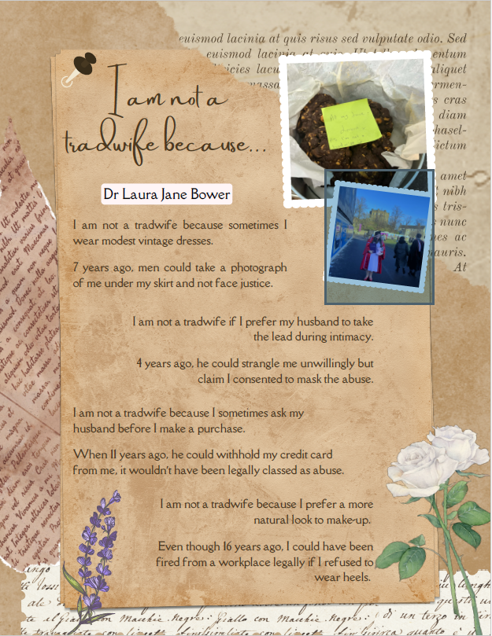
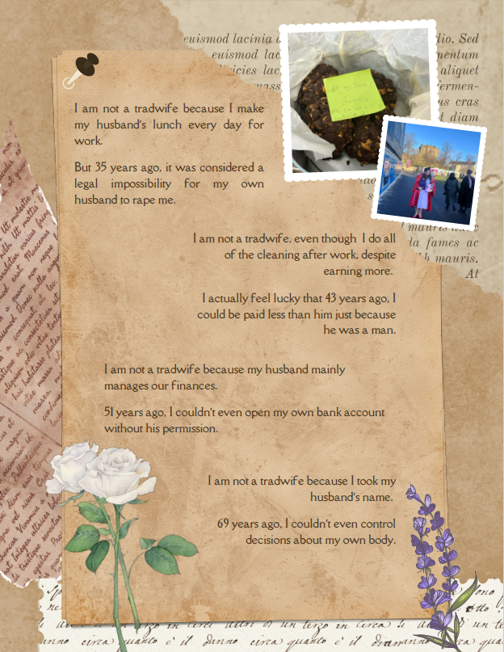
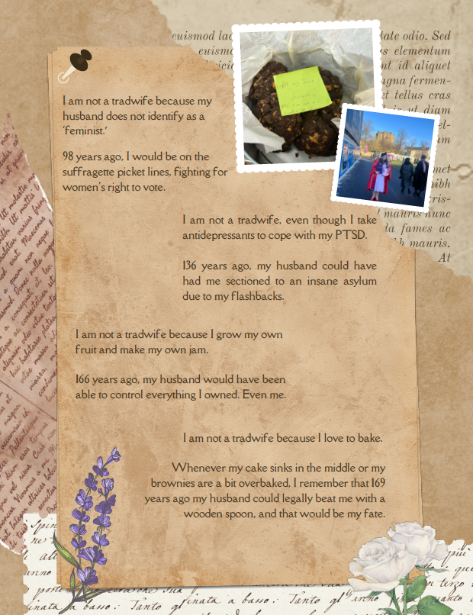

Exegesis
Sometimes I struggle with how much my research actually bleeds into my everyday life. As a very vocal feminist who studies violence against women and the implications of the tradwife movement for public understandings of gendered abuse, I often feel caught in the trap of needing to defend my personal life. When, really, my own personal relationship should be able to remain private. Yet considerations of positionality and reflexivity are essential for truly appreciating the nuances of lived experience, the contours of research, and the dynamics of power. So, researchers examining crime and victimisation do need to reflect on the impact their personal identity may have on the research journey.
Does this place a lot of pressure on researchers to truly embody their research? Sometimes, yes.
Would it be odd for a Green Criminologist to make no effort to recycle at home? Probably.
Or a cybercrime specialist to have no virus protection software on their personal devices? Most definitely.
How about a burglary expert never locking their front door? Without question.
It certainly makes sense in some areas, but when we consider the emotional toll our research can take, it feels like either an unspoken rule we are constantly trying not to break or a cloud hanging over our heads. I research and write about traditional marriages, and it leaves me feeling very vulnerable and open to scrutiny about my own relationship.
In this poem, I wanted to illuminate the reality of what it can be to study victimisation; it can be affective well beyond the research process. I still worry, and twist myself in knots, wondering if I am some sort of massive hypocrite or traitor to feminism for engaging in tasks of domesticity that knock on the door of tradwives.

